**BABEL, ISAAC (БАБЕЛЬ, ИСААК) (1894-1940)**

Known primarily for his short fiction, Isaac Babel was one of the most important literary figures of early Soviet Russia. He was born in 1894 to a Jewish family in Odessa, a city that figures prominently in his writing. Babel rose to both national and international fame in the mid 1920s with *Red Cavalry* (*Konarmiia*), a cycle of stories depicting General Semen Budenny’s ruthless military campaign in Poland. Although he continued to write through the thirties, Babel was forced to do so cautiously due to the rising political and creative repression under Stalin. By 1934 he was effectively reduced to what he called ‘the genre of literary silence.’ Arrested on trumped-up charges of espionage, the author was executed in 1940. His work was banned until he was formally exonerated in 1954.

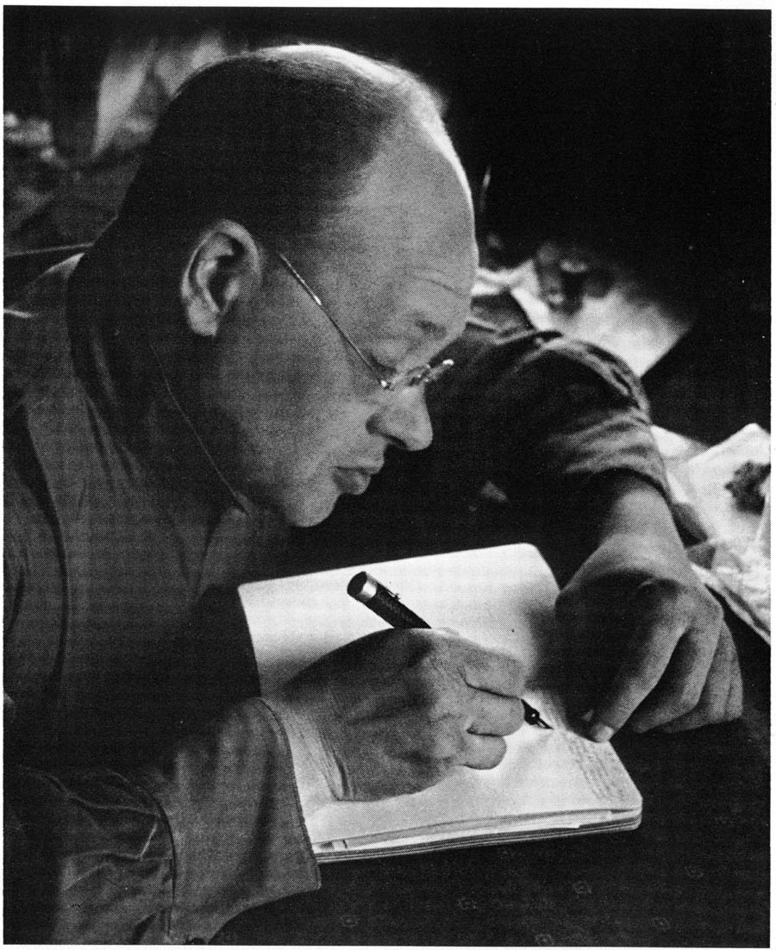 Isaac Emmanuilovich Babel was born to a middle-class Jewish family on July 13 (June 30 Old-Style), 1894, and spent his childhood in Nikolaev and Odessa. This illustrious port city on the Black Sea became the setting for the author’s *Odessa Tales* (*Odesskie rasskazy*) (1923-1932), about the life and times of Jewish gangsters, as well as most of his childhood stories (1915-1937), which are largely fictionalized accounts of his experience growing up.

Isaac Babel writing at

his desk in 1933.

Babel made his authorial debut in 1913 with “Old Shloyme” (“Staryi Shloime”) which appeared when he was still a student at the Institute of Business and Finance in Kiev. Besides stories and sketches, which he published in various journals, Babel wrote journalistic prose and would later expand to plays, screenplays, and translations (he knew French, Yiddish, Hebrew, English, and German). He moved to St. Petersburg (Petrograd) in 1916, where he met the famous writer Maxim Gorky and became his protégé and lifelong friend. It was in 1920, however, that Babel was afforded the opportunity that launched his authorial career: He was assigned to General Budenny’s Cavalry Army as a war correspondent. The journal he kept during his experience on the Polish front became fodder for his *Red Cavalry* stories which catapulted him to national and international fame. Ironically, this was also the cycle that first cast doubt on Babel’s ideological integrity as a result of the vicious, public accusations of political dishonesty leveled at the author by Budenny himself.

Among the most celebrated “Fellow Travelers”—a term adopted by Leon Trotsky to describe non-party authors who nonetheless sympathized with the goals of the Revolution—Babel was, throughout his career, reluctant to conform. Affiliated neither with a specific literary movement nor the Party, and always tinkering with his biography, he frustrated attempts to pin him down. His writing was deeply influenced by the work of Maupassant, Gogol, Tolstoy, and Sholem Aleichem, and he is remembered as an unrelenting craftsman of brilliant, economical prose. When his mother and wife emigrated to Western Europe in the mid 1920s, Babel refused to follow, insisting that it was essential for him as a Russian author to remain in his homeland. Once Stalin came to power, restrictions on the style and content of creative output began to mount alarmingly and Babel’s literary production was severely reduced. Between 1929 and 1933 he published only a handful of stories, and by the First Congress of Soviet Authors in 1934, he announced that he had begun to practice the genre of ‘literary silence.’ In 1939, three years after the death of Gorky, who had been the author’s constant guardian angel, Babel was arrested and imprisoned on trumped-up charges of espionage. He was executed at the infamous Lyubianka prison on January 24, 1940 and only rehabilitated fourteen years later.

**Major Works by Isaac Babel**

**Story Cycles**

*Odessa Tales* (*Odesskie rasskazy*, 1921-1932)

*Red Cavalry* (*Konarmiia*, 1926)

**Stories**

“Old Shloyme” (“Staryi Shloime,” 1913)

“The Story of my Dovecote” (“Istoriia moei golubiatni,”1925)

“First Love” (“Pervaia liubov’,”1925)

“Awakening” (“Probuzhdenie,” 1931)

“In the Basement” (“V podvale,” 1931)

“Karl-Yankel” (“Karl-Iankel’,” 1931)

“Guy de Maupassant” (“Giui de Mopassan,” 1932)

“Gapa Guzhva” (“Gapa Guzhva,”1931)

“Di Grasso” (“Di Grasso,” 1937)

“My First Fee” (“Moi pervyi gonorar,” 1963, published posthumously)

**Plays**

*Sunset* (*Zakat*, 1928)

*Maria* (*Mariia*, 1935)

**Screenplays**

*Roaming Stars* (*Bluzhdaiushchie zvezdy*, 1926)

*Benya Krik* (*Benia Krik*, 1926)

**Non-Fiction**

“Odessa” (“Odessa,” 1916)

*Reports from St. Petersburg* (no collective title in the original, 1918)

*1920 Diary, Dnevnik 1920ogo goda*

“Line and Color” (“Liniia i tsvet,” 1923)

Speech given at the First Congress of Soviet Writers (Rech’ na pervom vsesoiuznom s”ezde sovetskikh pisatelei, 1934)

**References and Further Reading**

**Biography**

Freidin, Gregory (1989) “Isaac Babel.” *European Writers: The Twentieth Century*,

volume 2, 1884-1914, edited by George Stade. New York: Scribner’s. A thorough and sensitive biographical essay.

Pirozhkova, Antonina (1996) *At His Side: The Last Years of Isaac Babel*, South

Royalton, Vt.: Steerforth Press. Written by the author’s second wife.

**Selection of Critical Works**

Bloom, Harold (edited by) (1987) *Modern Critical Views: Isaac Babel*, New

Haven, Conn.: Chelsea House. Includes a number of classic critical essays on Babel.

Falen, James. (1974) *Isaac Babel: Master of the Short Story*. Knoxville: The

University of Tennessee Press. An examination of the author’s biography and art largely by way of *Odessa Tales* and *Red Cavalry*.

Freidin, Gregory (edited by) (2009) *The Enigma of Isaac Babel: Biography, History*,

*Context*, Stanford: Stanford University Press. A collection of essays by some

of the leading scholars on Babel.

Sicher, Efraim. (1986) *Style and Structure in the Prose of Isaac Babel*. Columbus:

Slavica Publishers. A study focused on the linguistic intricacies of Babel’s

writing in the twenties.

**Janneke van de Stadt, Williams College**

**Photograph**

Isaac Babel writing at his desk in 1933.

http://www.stanford.edu/group/isaac_babel/images/press/isaac_babel1933_petrusov.jpg